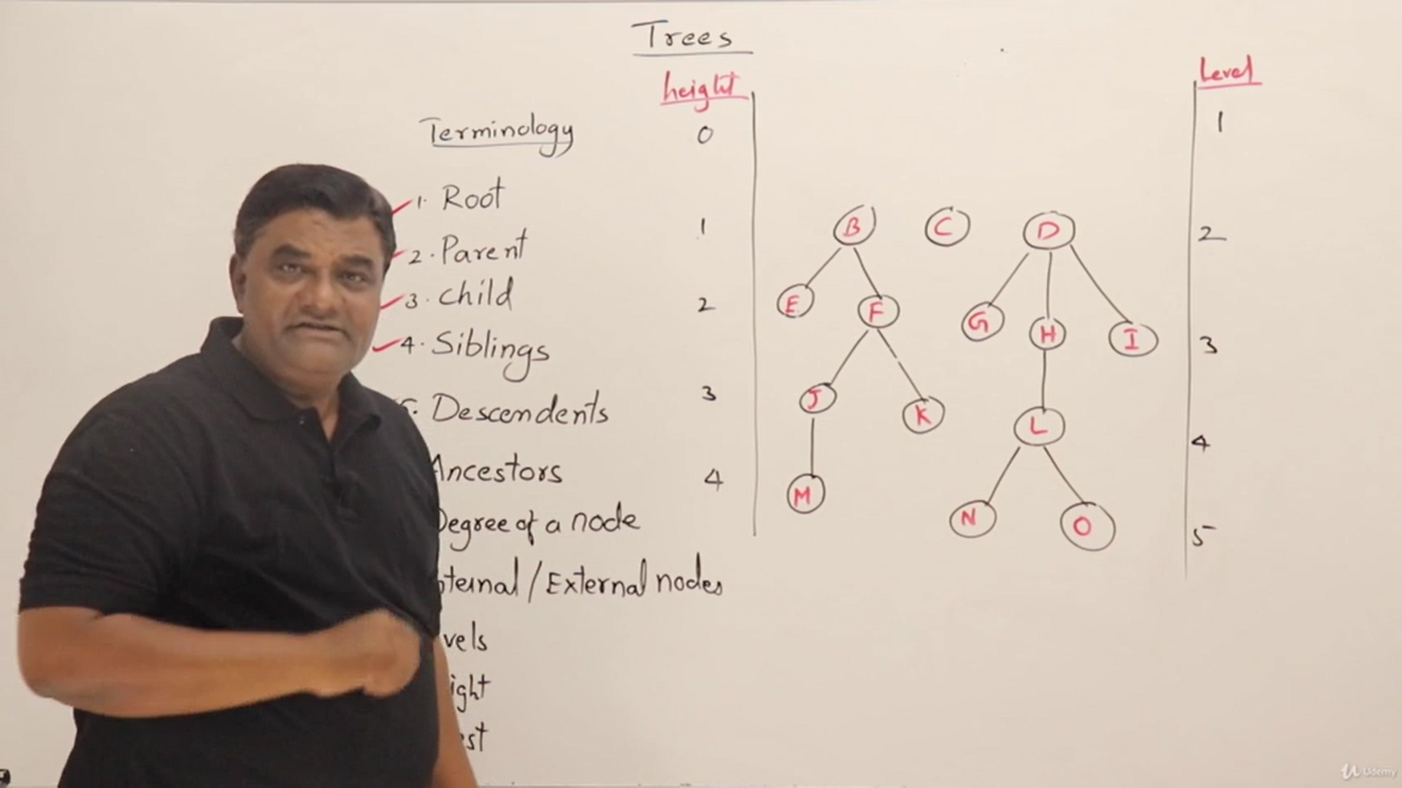

height 🡪 starts from the edges

level 🡪 starts from the node

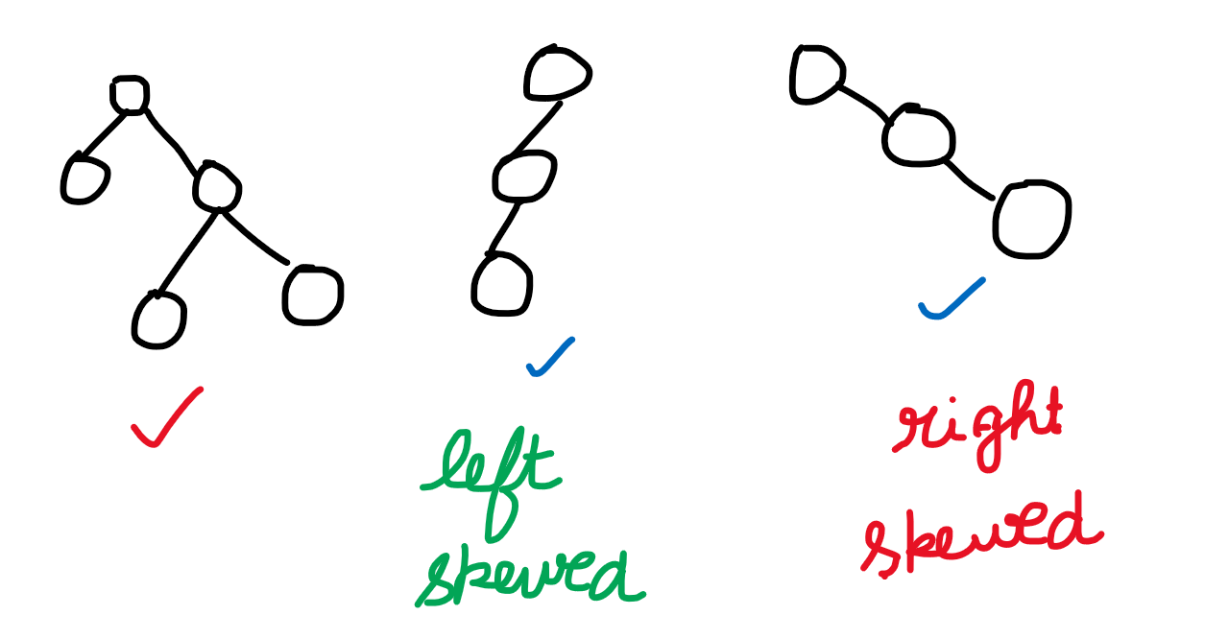

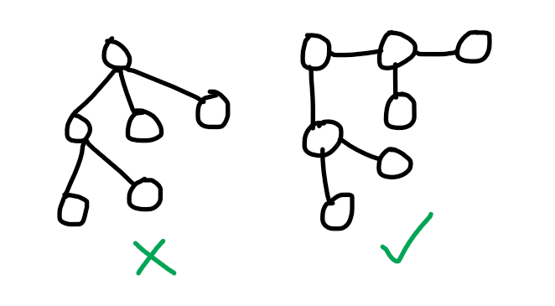

**Binary Trees**

**Unlabelled Nodes** **Labelled Nodes**

**Unlabelled Nodes**

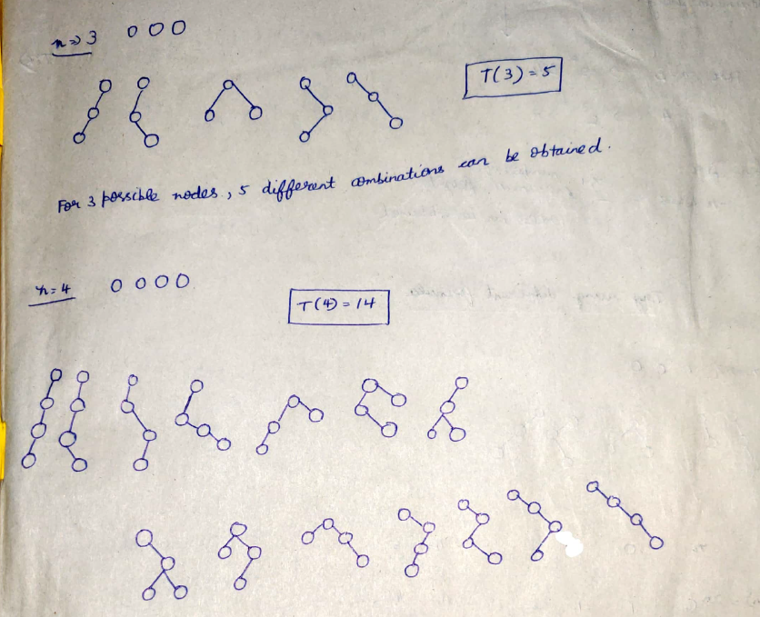  
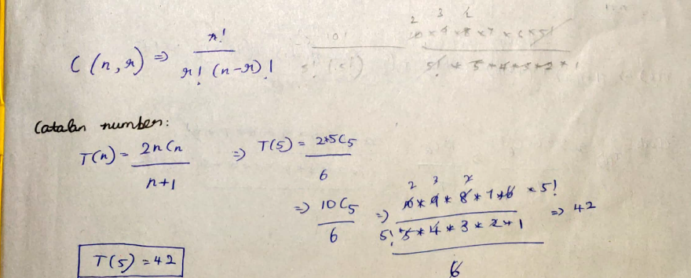

Number of binary trees with given unlabelled nodes 🡪   
Catalan Number T(n)=2*n Cn / (n+1) (or) T(n) = $\sum_{i=1}^{n}{[ T(i-1)*T(n-i) }]$  
Number of binary trees having maximum height 🡪 2^(n-1)

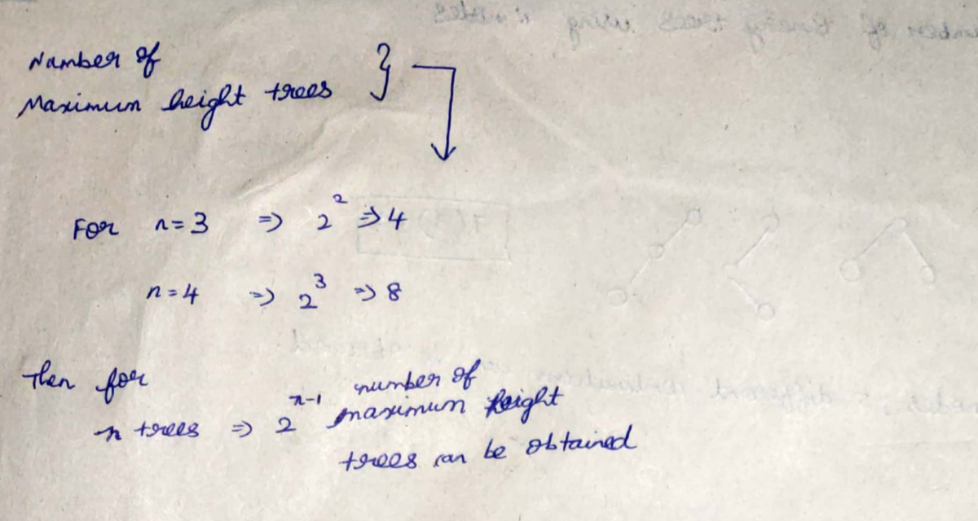  
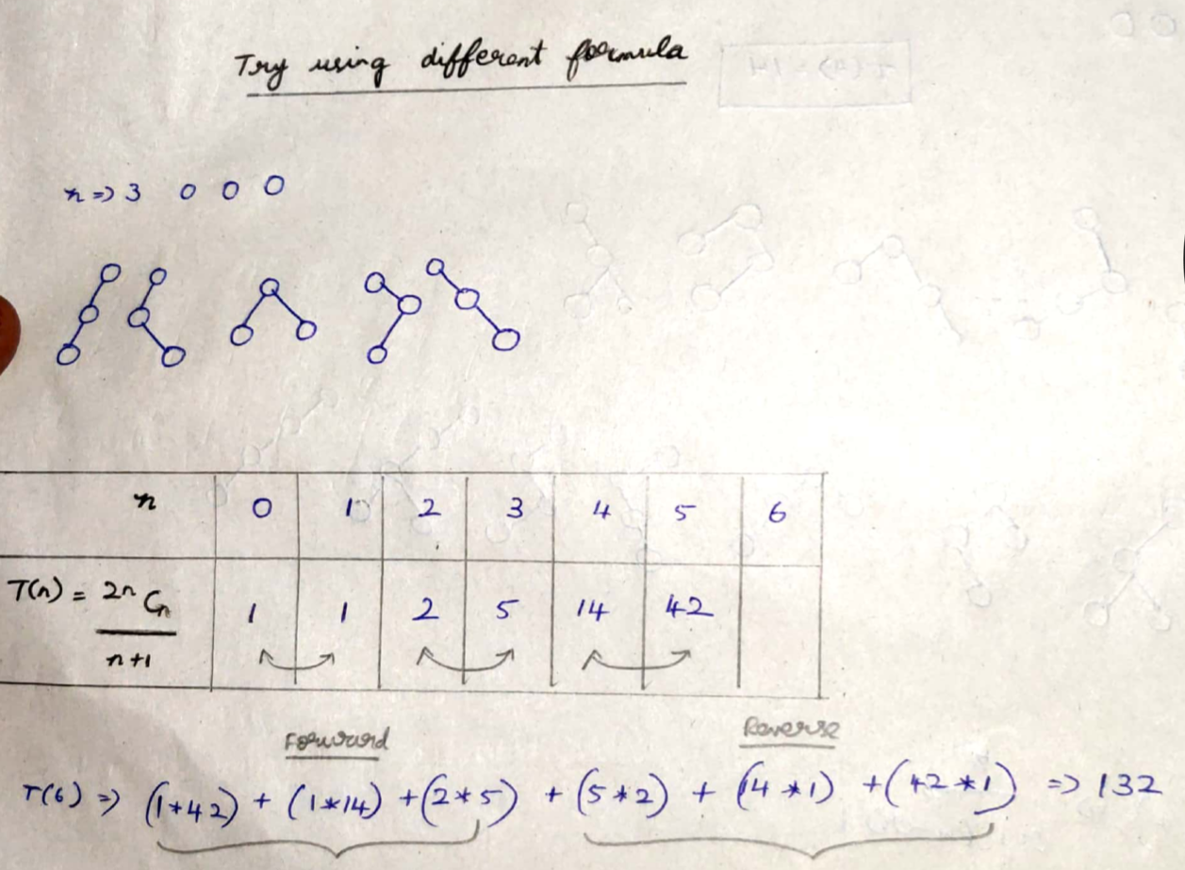

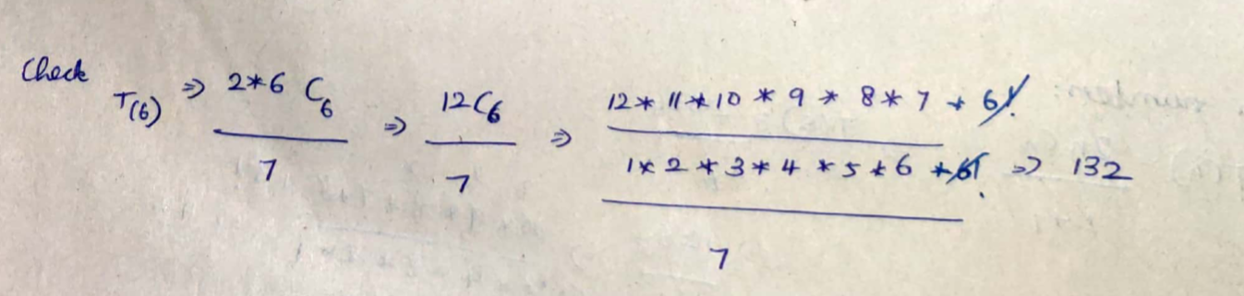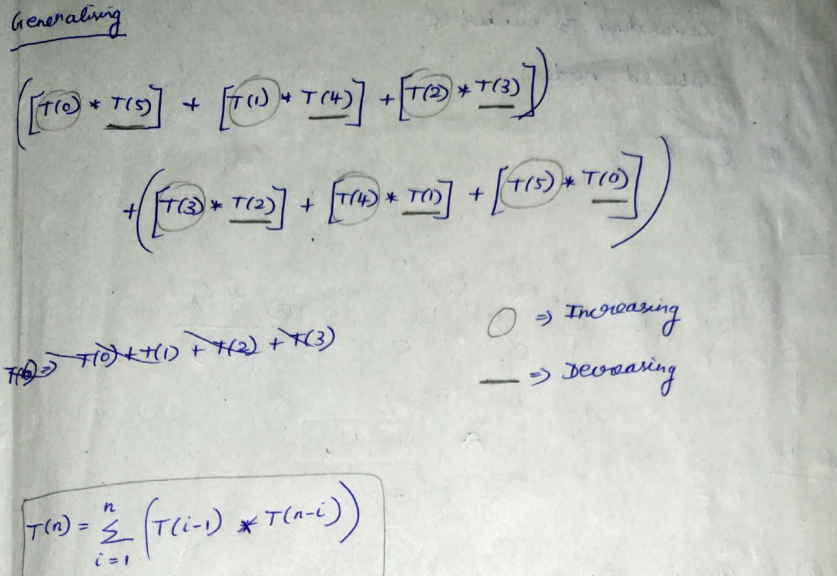  
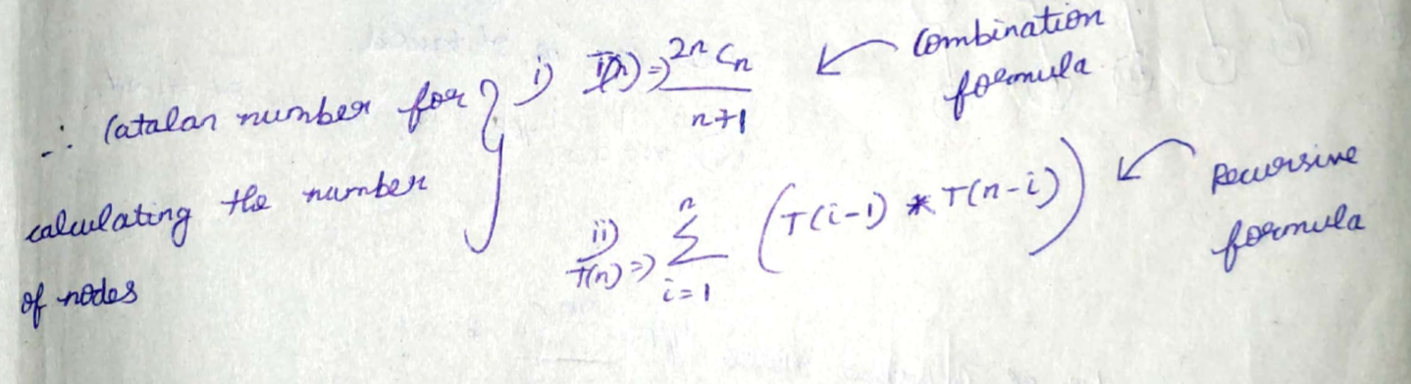

**Labelled Nodes**

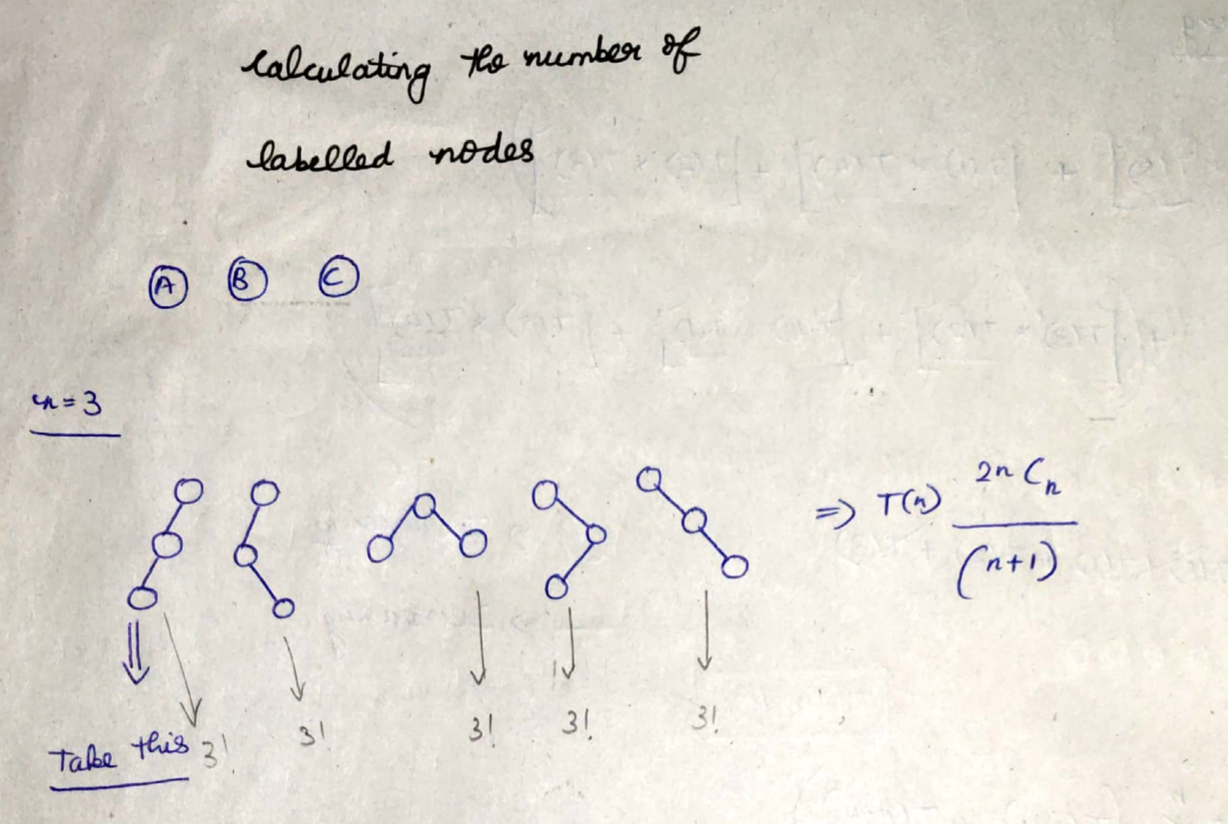  
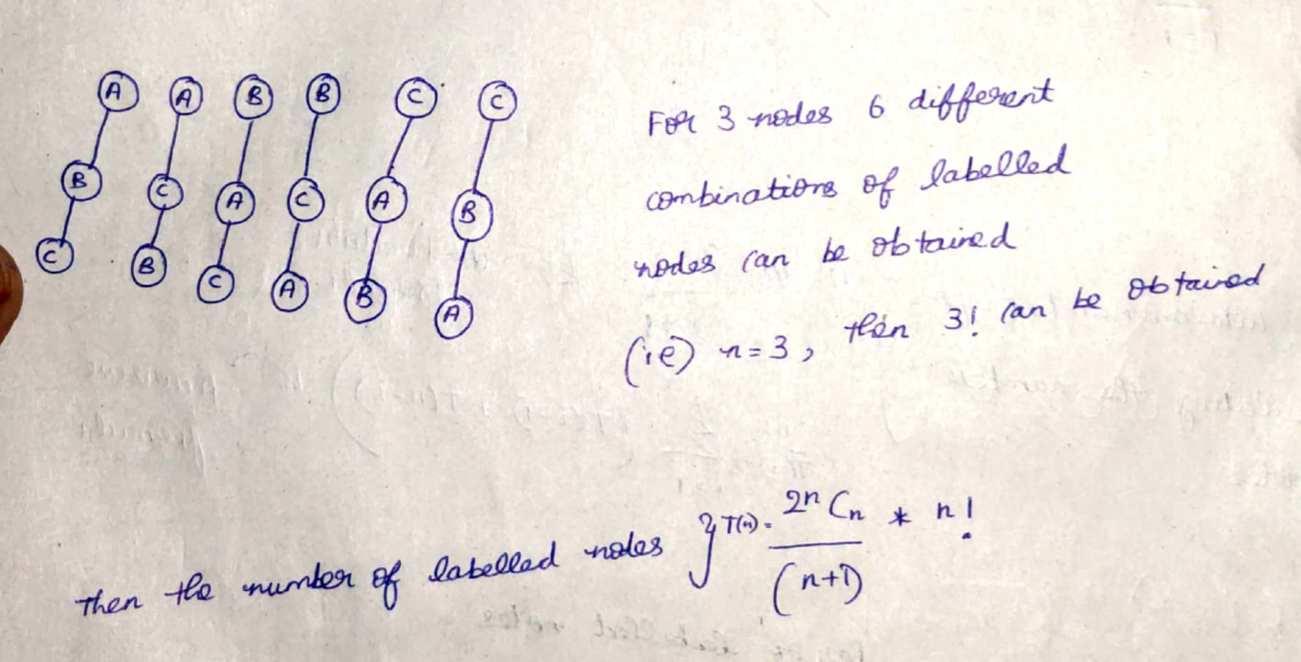  
Number of binary trees with given labelled nodes 🡪   
Catalan Number T(n) = (2*n Cn / (n+1) ) * n!

**Heights vs Nodes in Binary Trees**

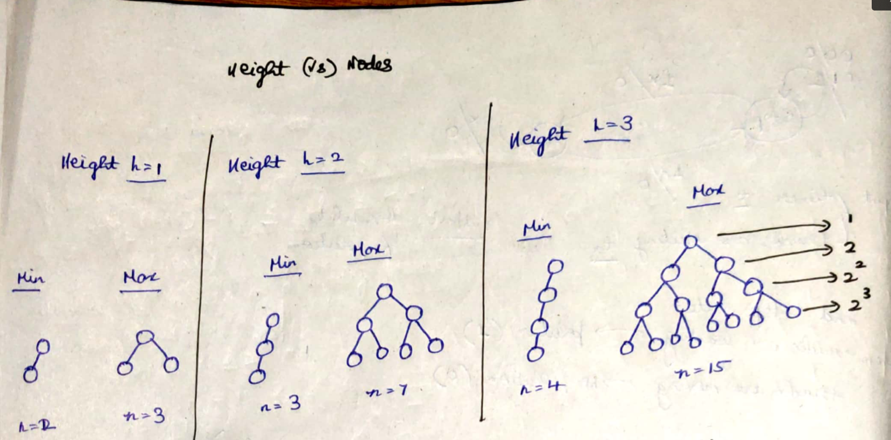  
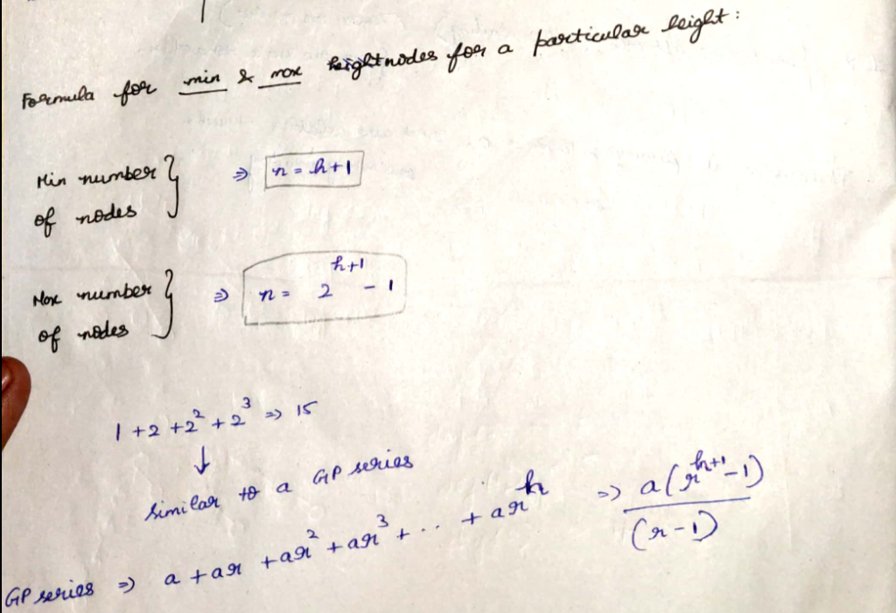





The above is the formula to calculate the number of nodes with given height.  
Find the height if the number of nodes are given

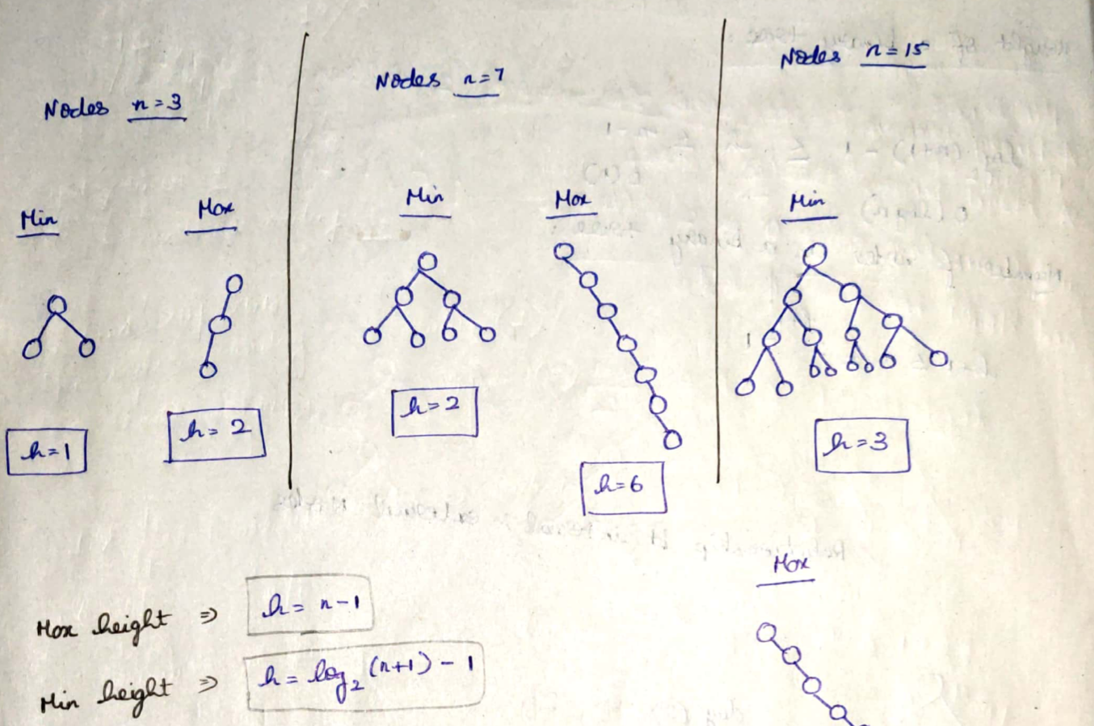  
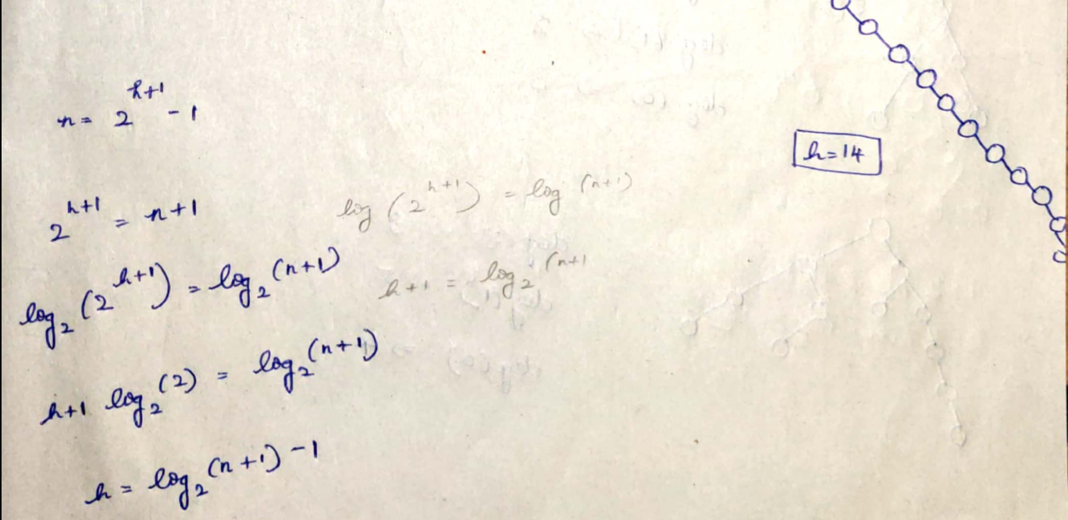



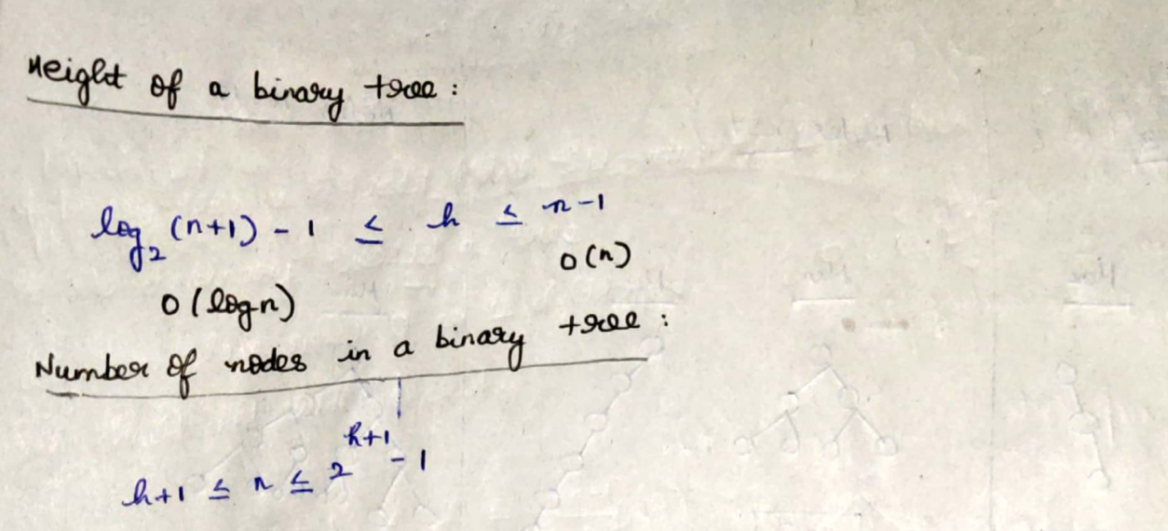

**Relation between Internal and External Nodes**

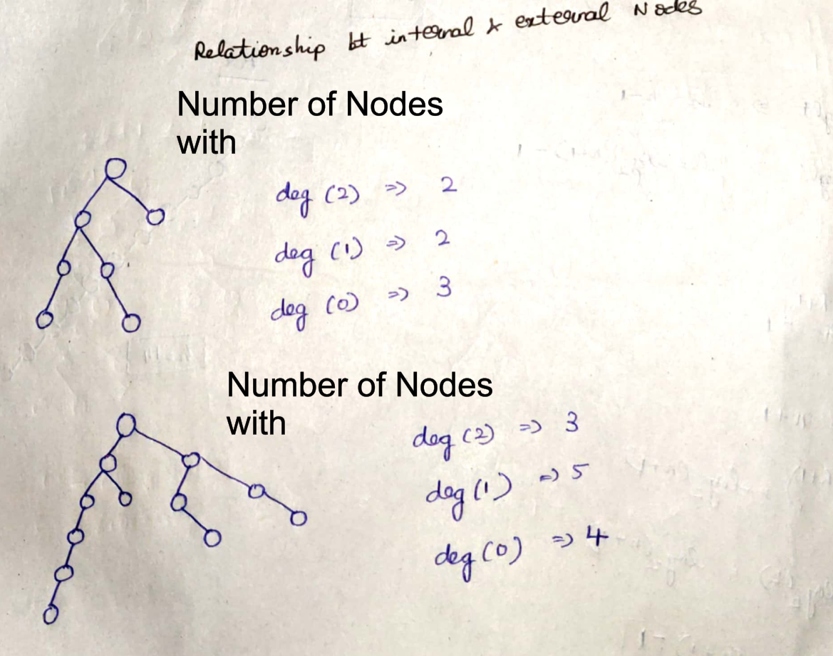

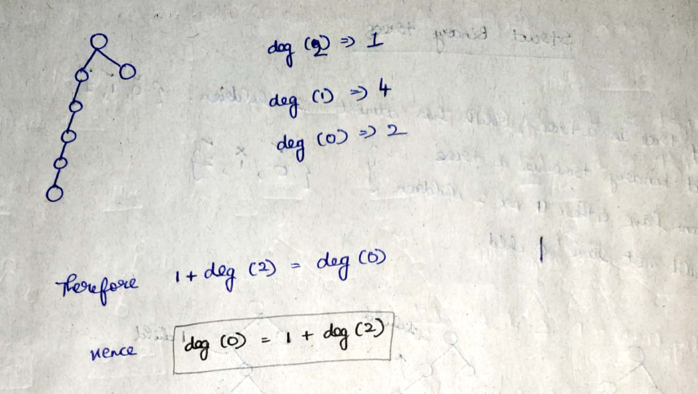

**For a binary tree,   
number of nodes with deg(0) = 1 + number of nodes with deg(2)**

**Strict Binary Trees**

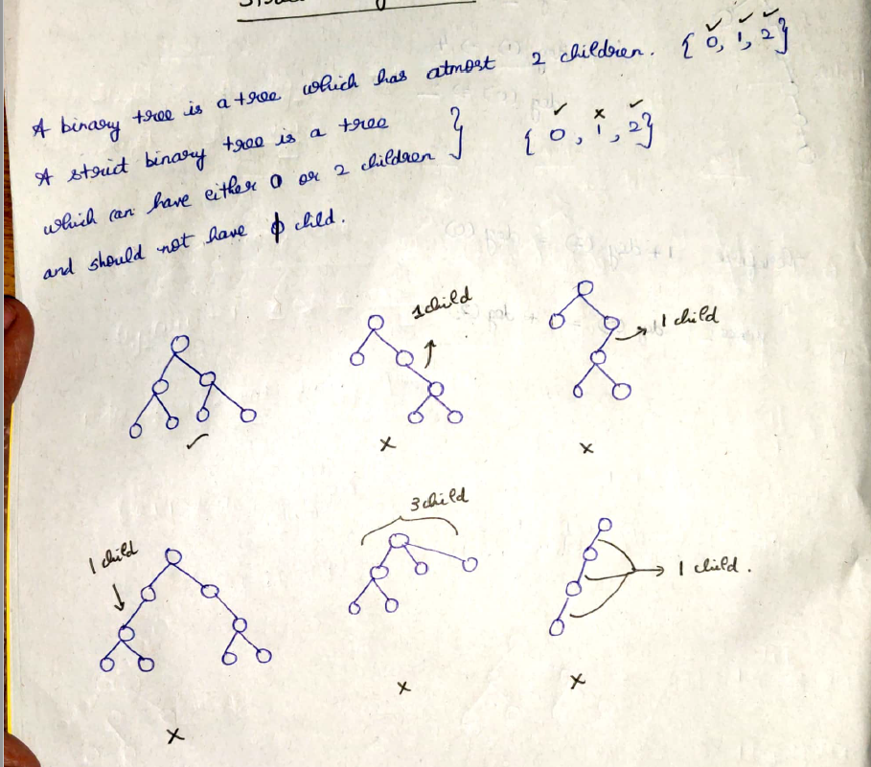 **Height vs Nodes in strict Binary Tree**

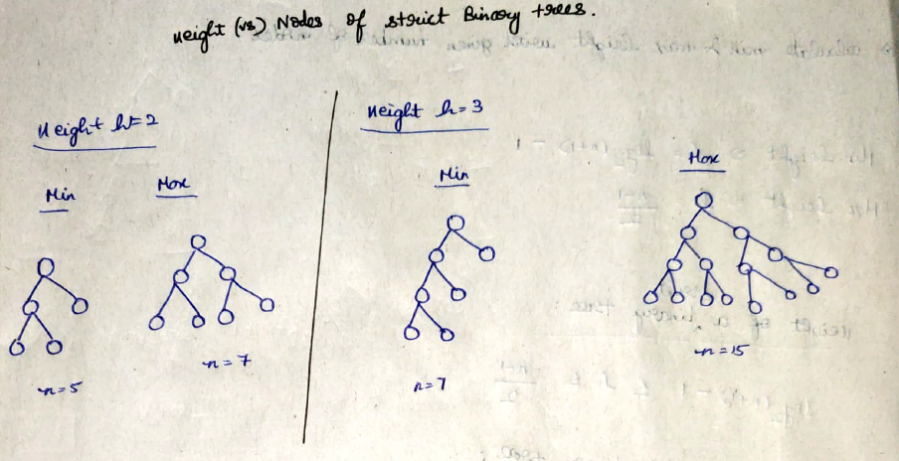

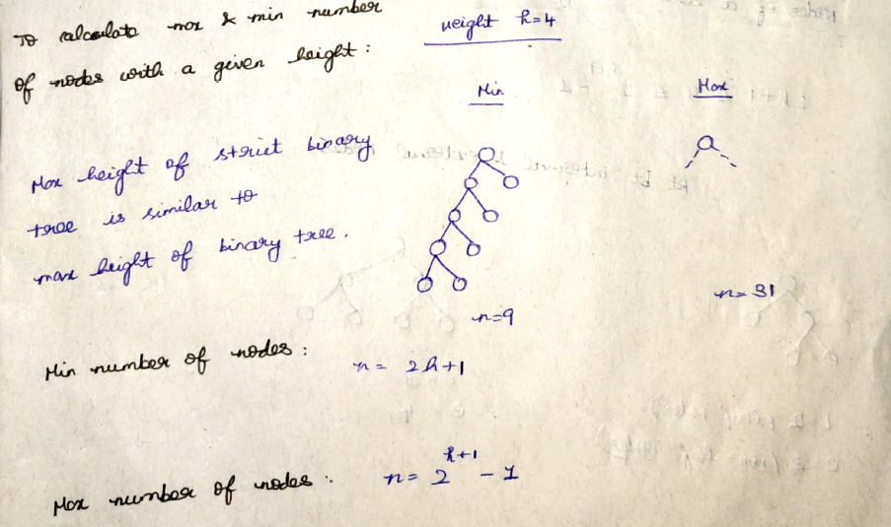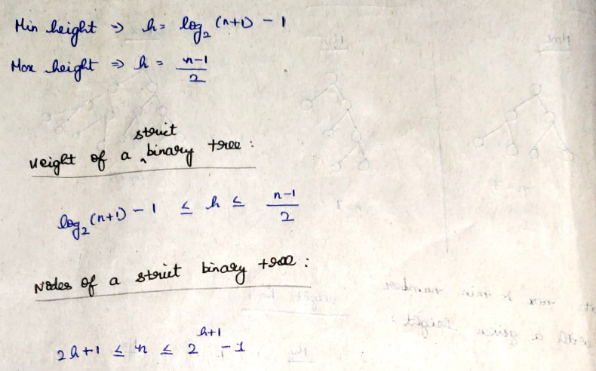





**Relation between Internal and External Nodes in strict binary tree**

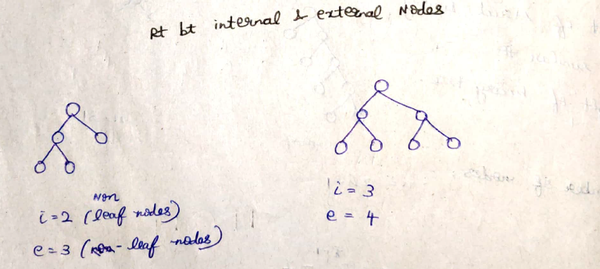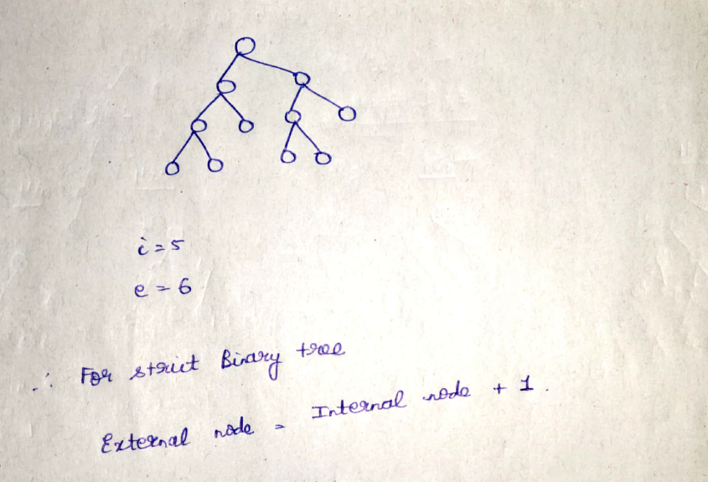

**For a strict binary tree, number of external nodes = 1 + internal node**

**M-array tree**

Every m-array tree can have at-most m nodes

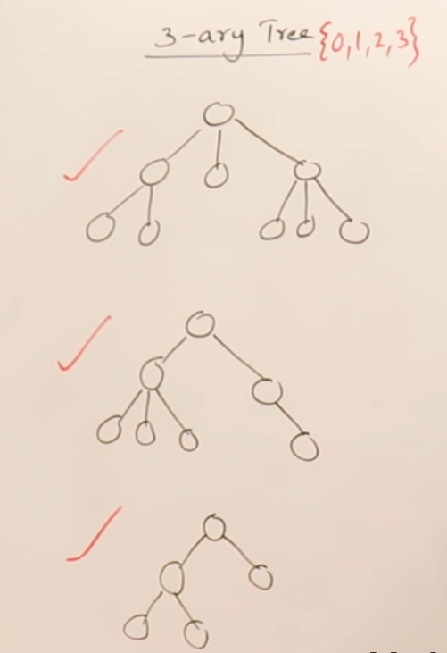 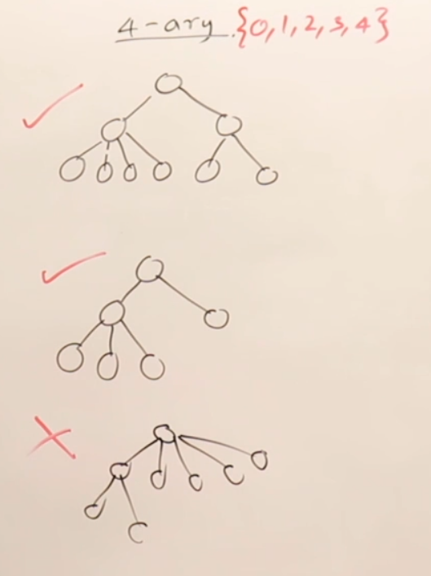

3 array tree can have atmost 3 nodes 4 array tree can have atmost 4 nodes

**Strict M-array tree**

Every strict m-array tree can have either 0 or m nodes.

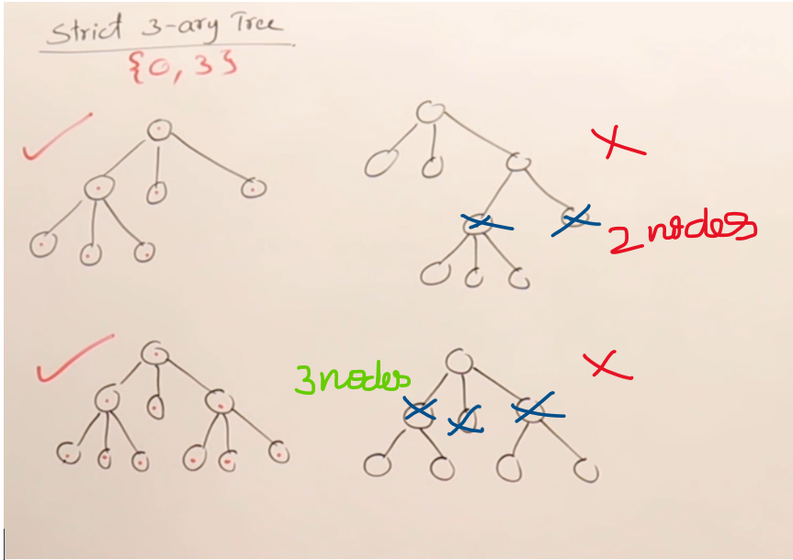

**Height and Nodes of a Strict m-array tree**

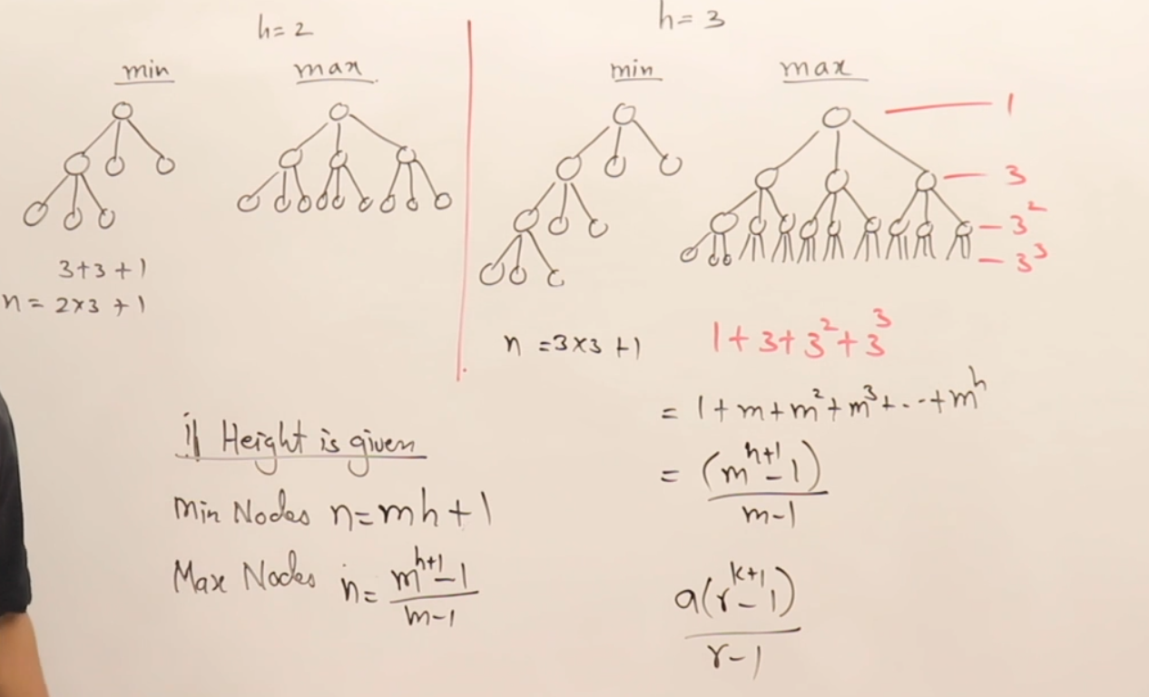



**Representation of a Binary tree**

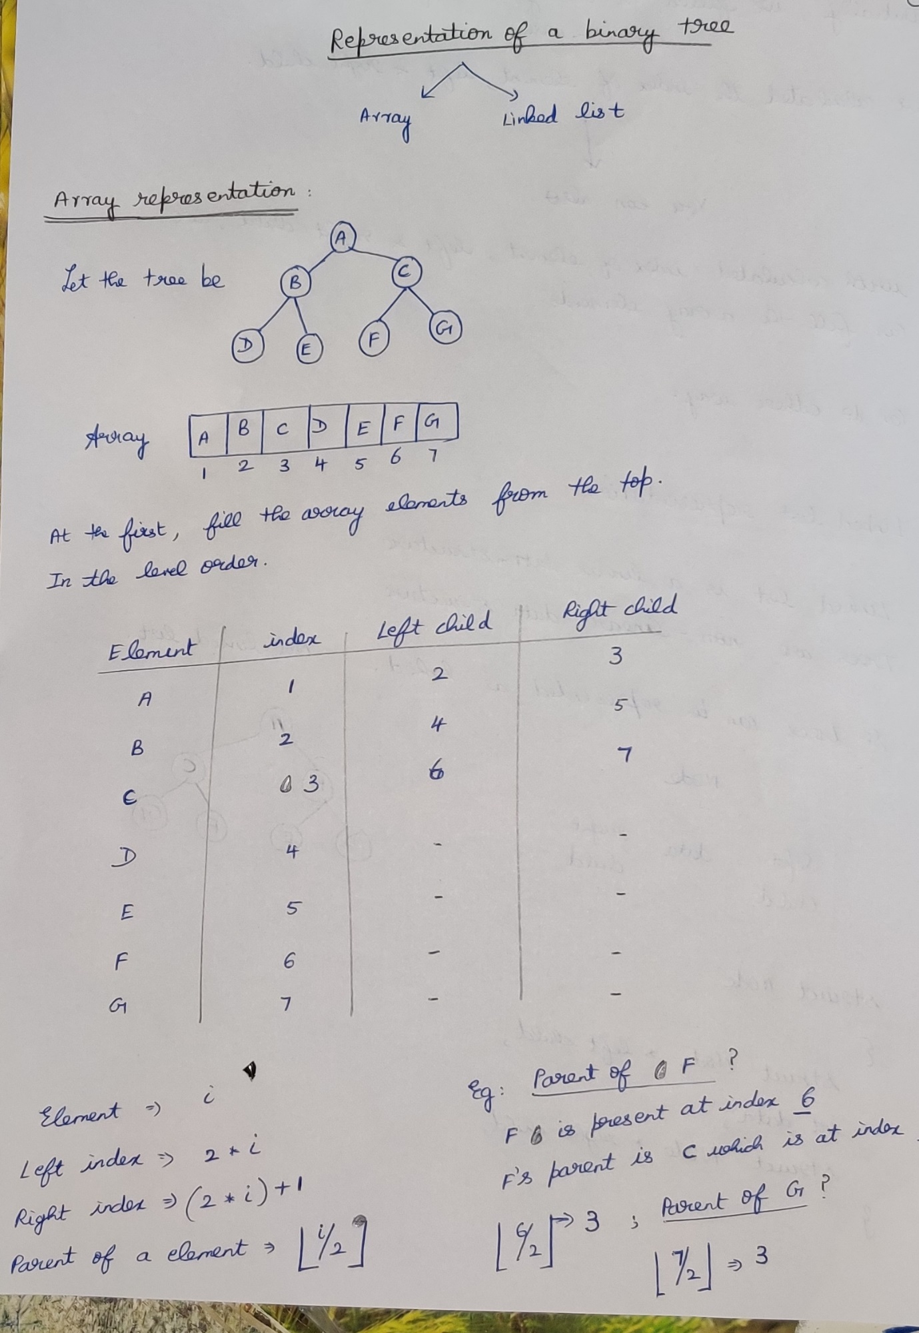

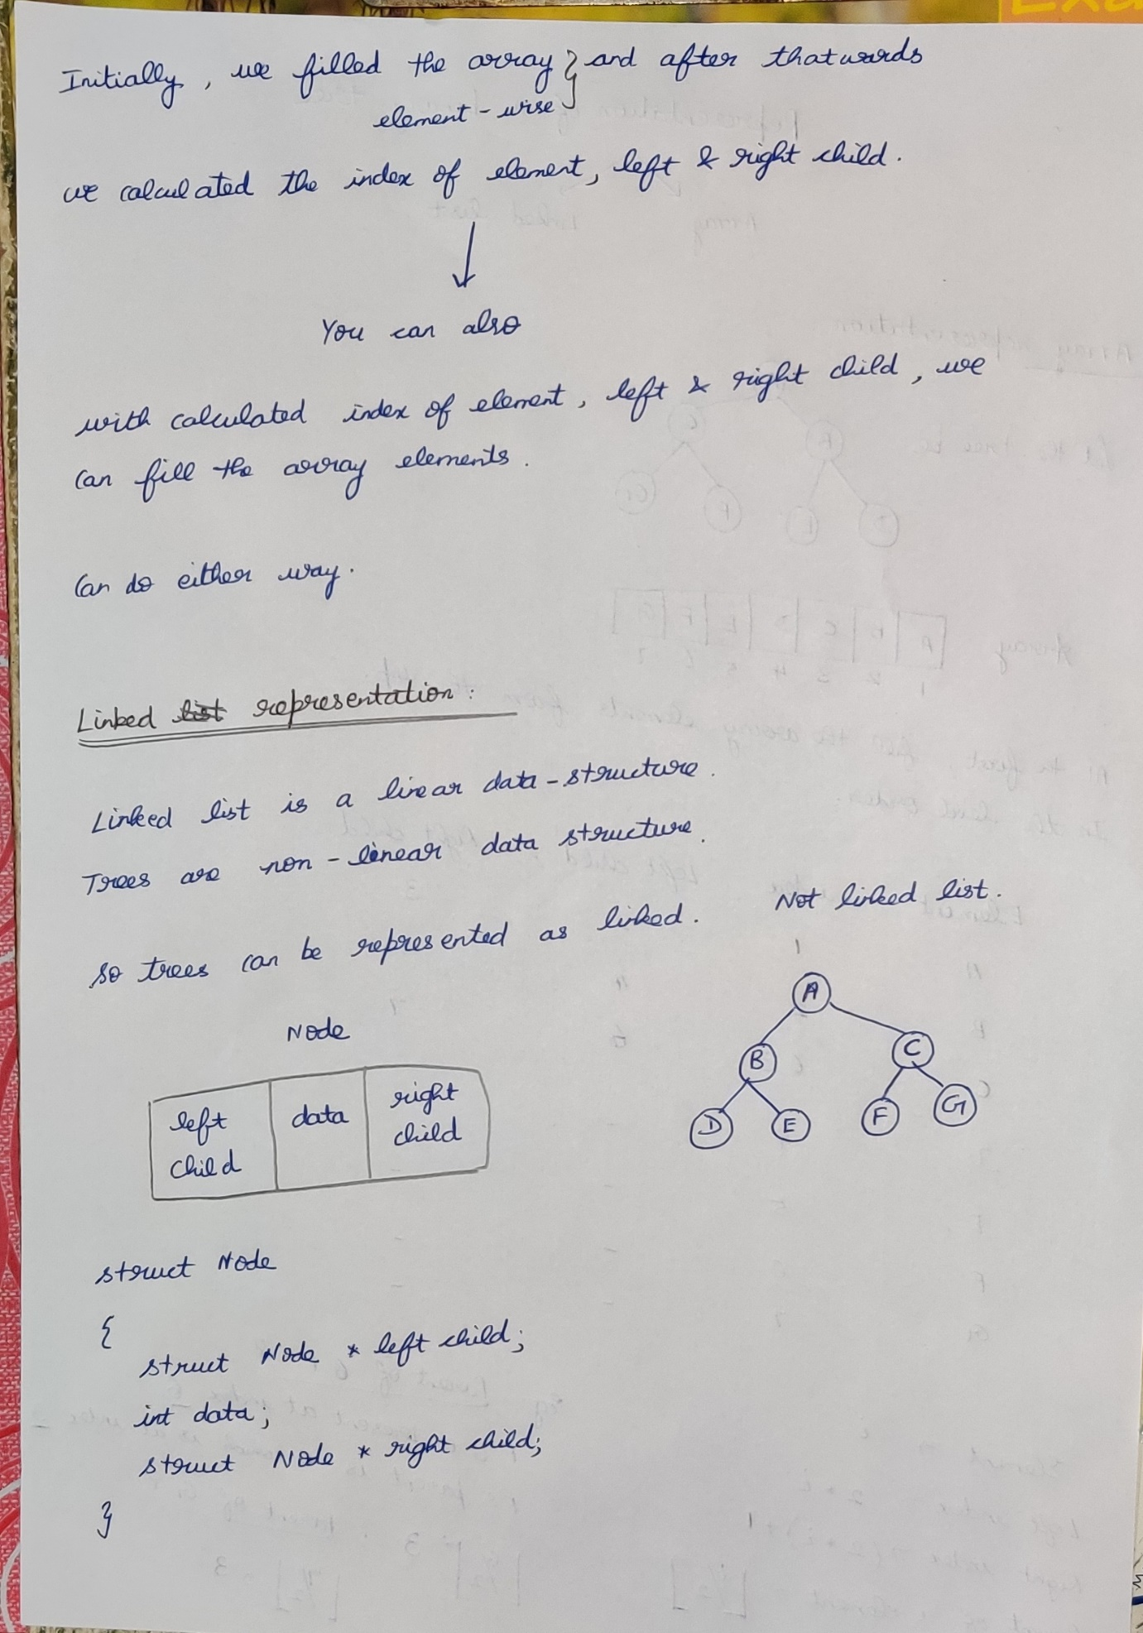

**Full Binary tree (vs) Complete Binary tree**

**Full Binary tree**A binary tree of height h having maximum number of nodes 🡪 Full Binary tree.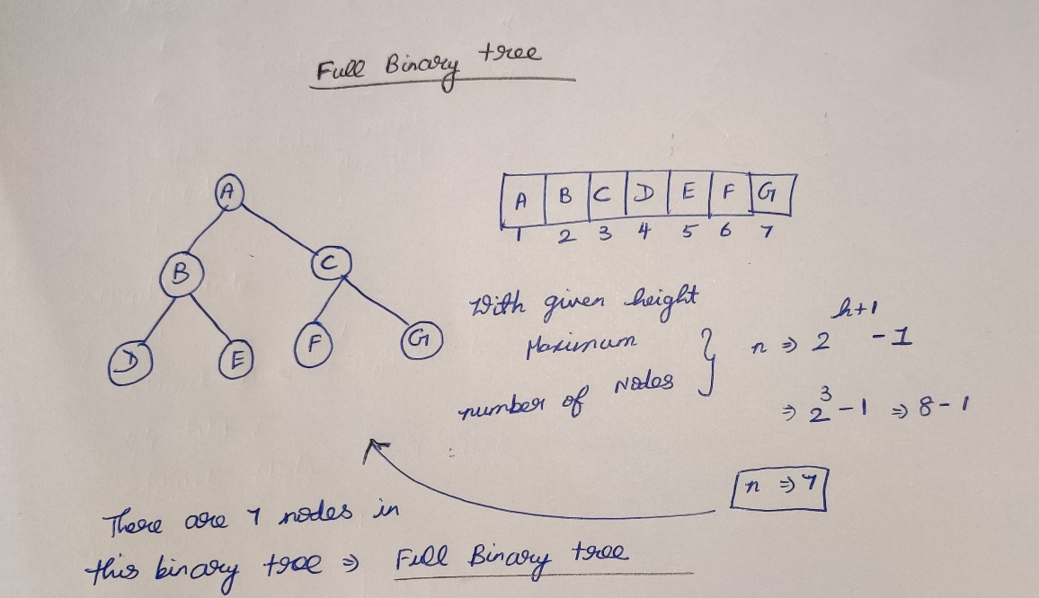

**Complete Binary tree**If a binary tree is represented in an array, then there should not be any blank spaces in-between the elements 🡪 complete binary tree,  
if there are blank spaces then 🡪 not a complete binary tree.

A complete binary tree of height h will be a full binary tree upto height (h-1), and at the last level the elements will be filled from left to right without skipping.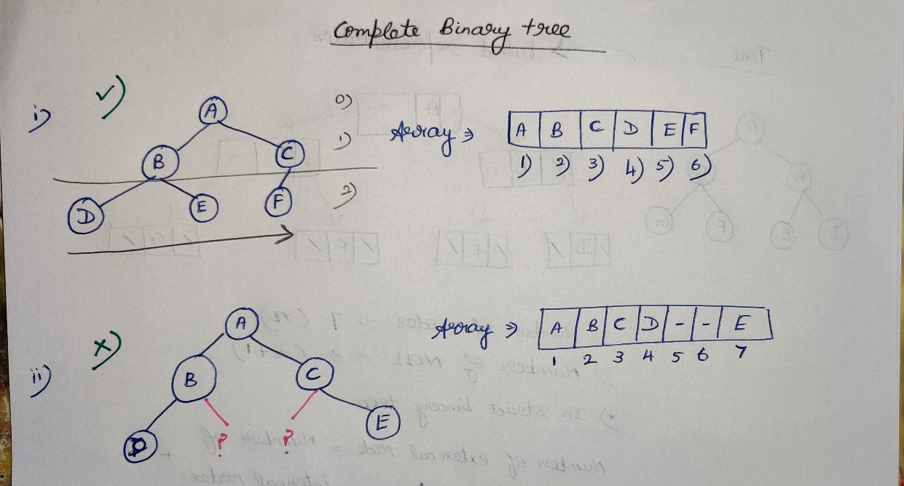  
A full binary tree is always a complete binary tree.

**Strict vs Complete Binary tree**  
 **Complete vs almost Binary tree**

There may be Strict binary complete and Complete Binary tree.  
There may be Complete binary tree and almost Binary tree.

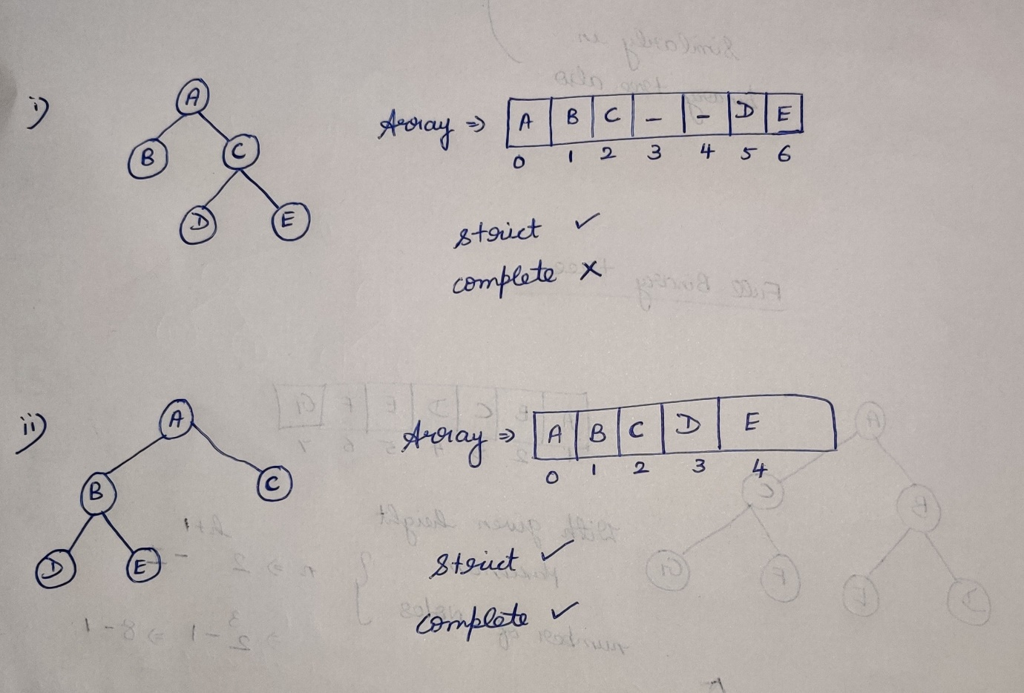  
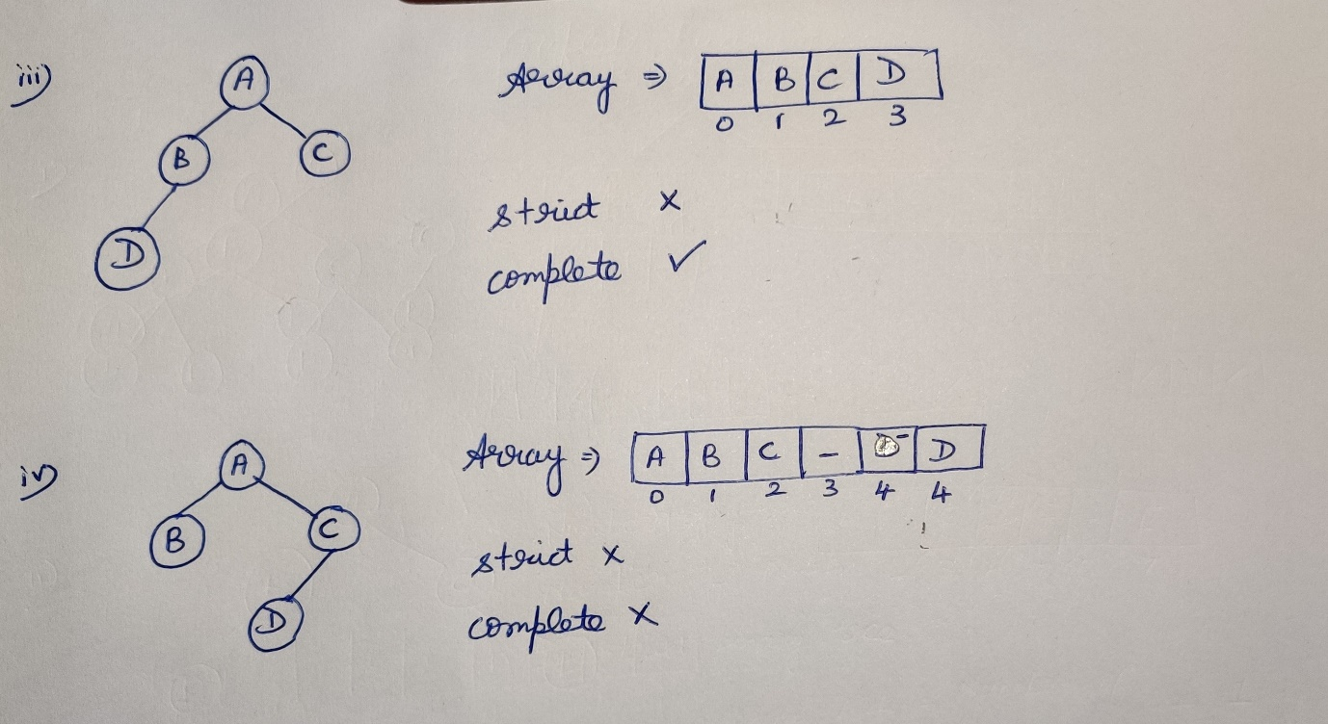

**Relation between Internal and External Nodes**

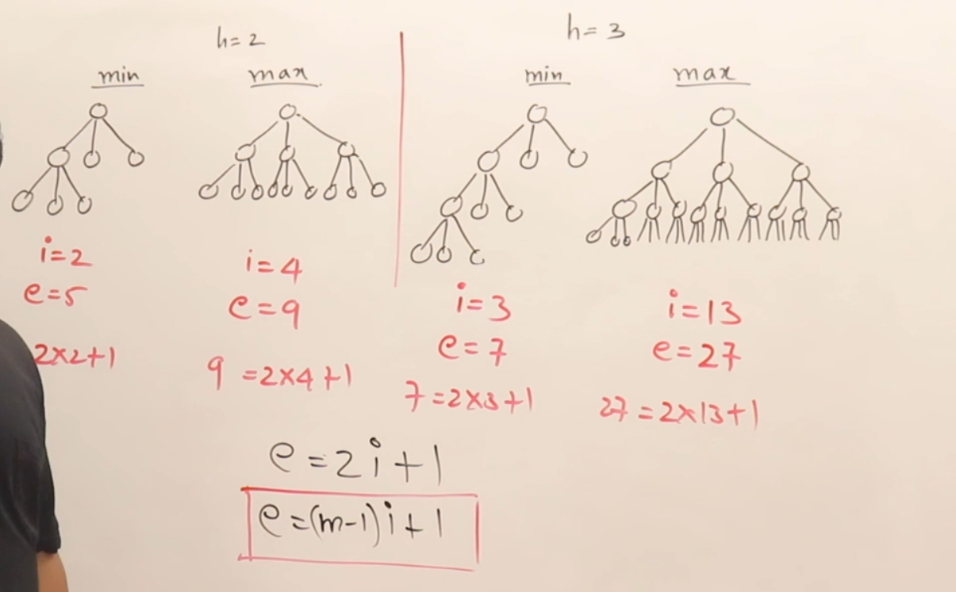

**Tree traversal**

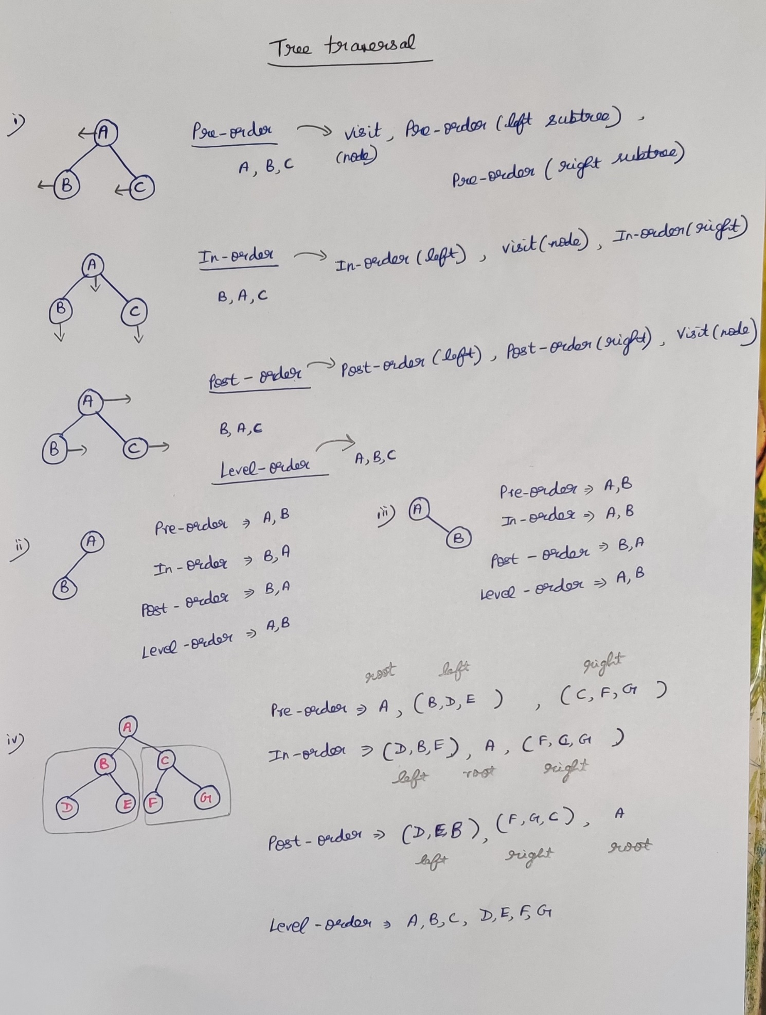

**Method-1**

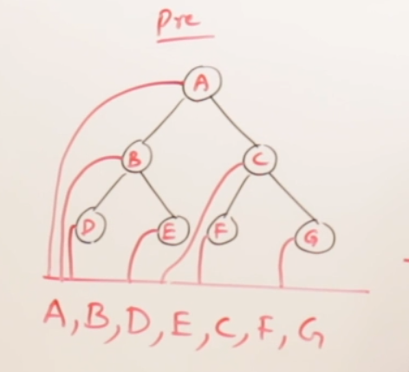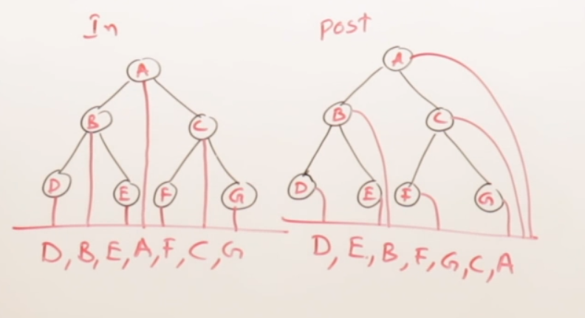

**Method-2**

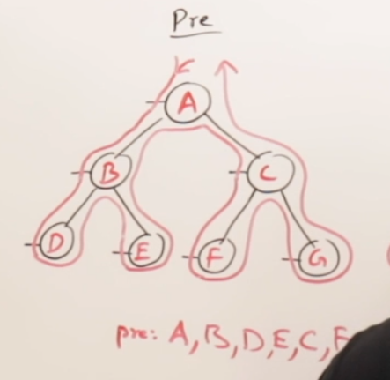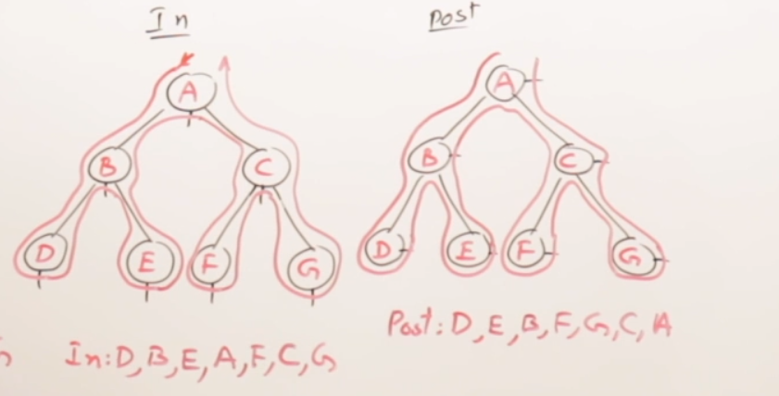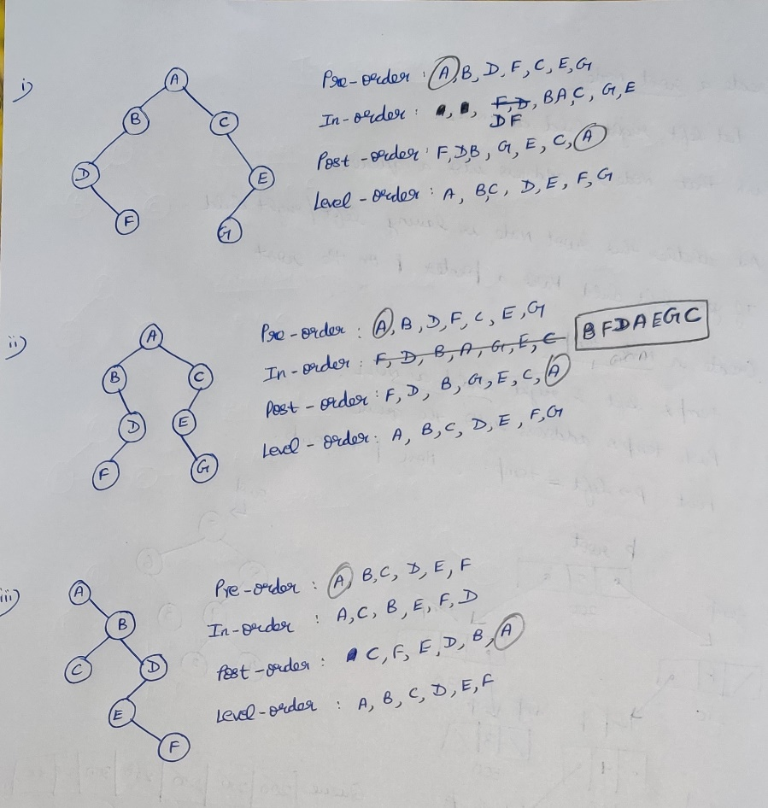

**Linked creation of a Binary Tree**

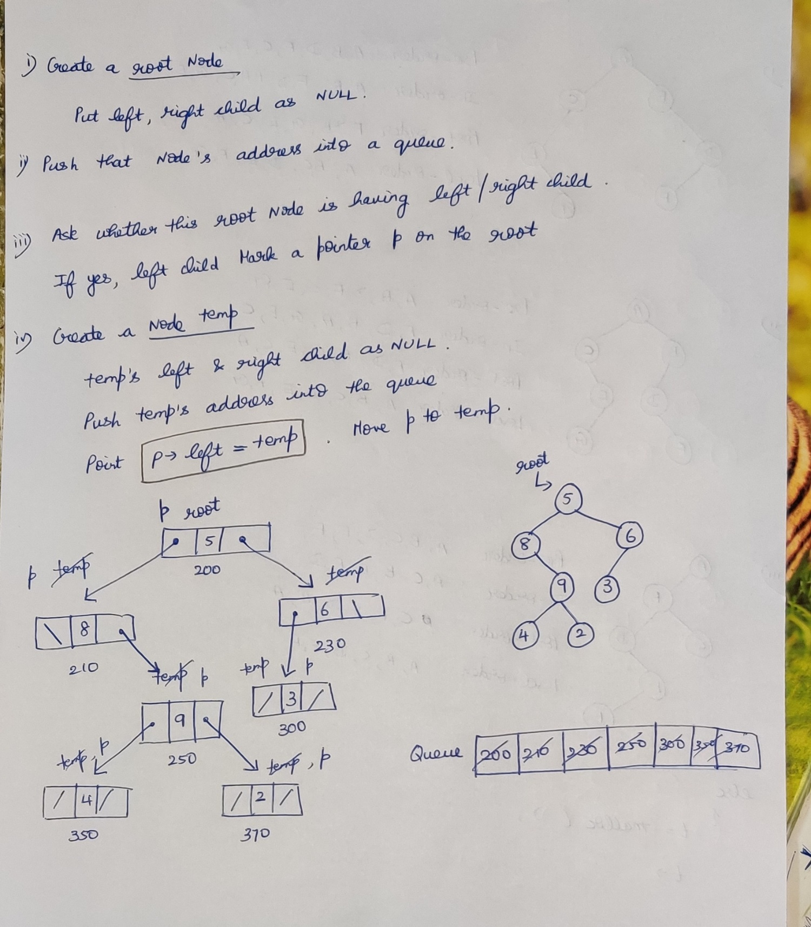

**Algorithm for creating a binary tree**

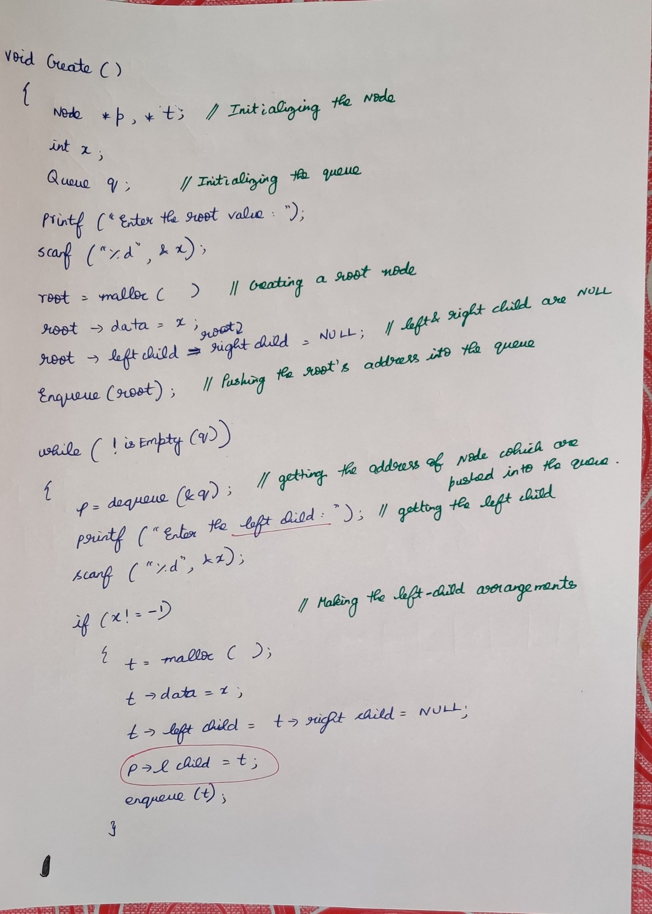

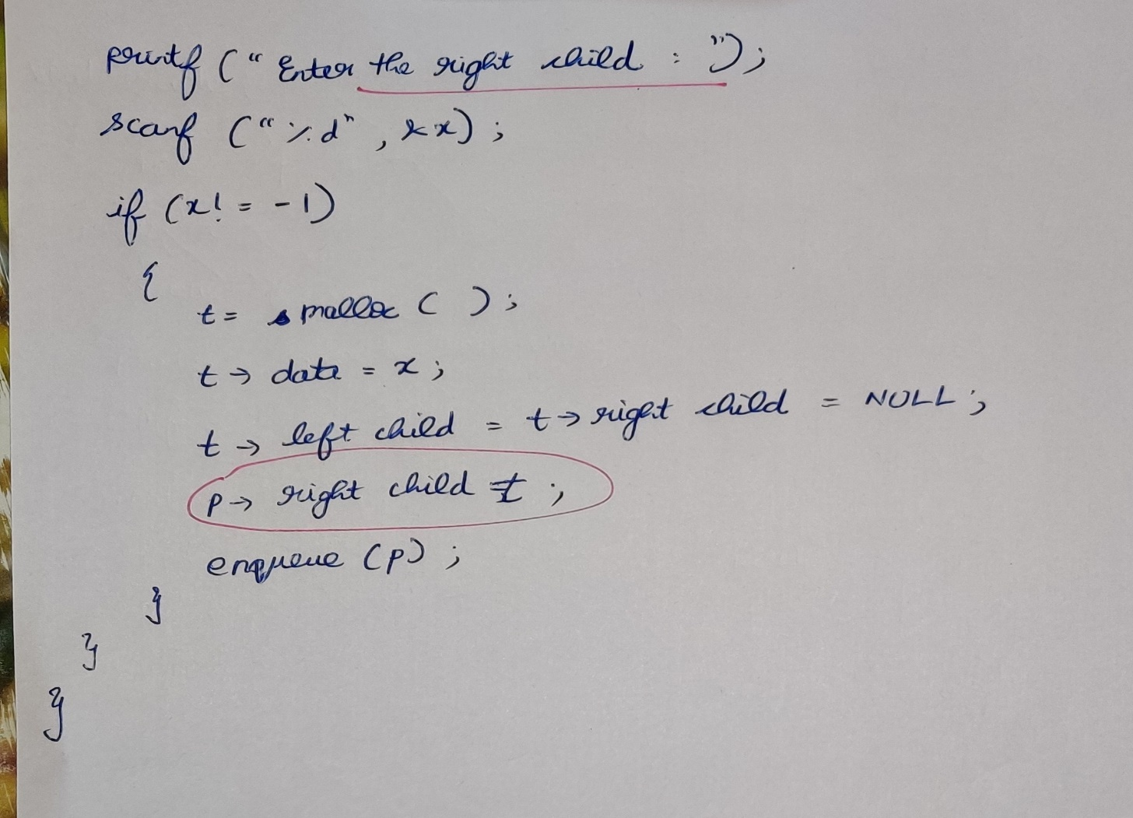

**Algorithm for tree traversal**

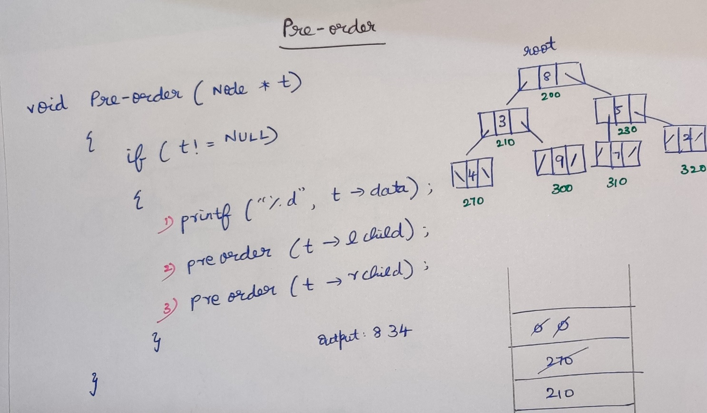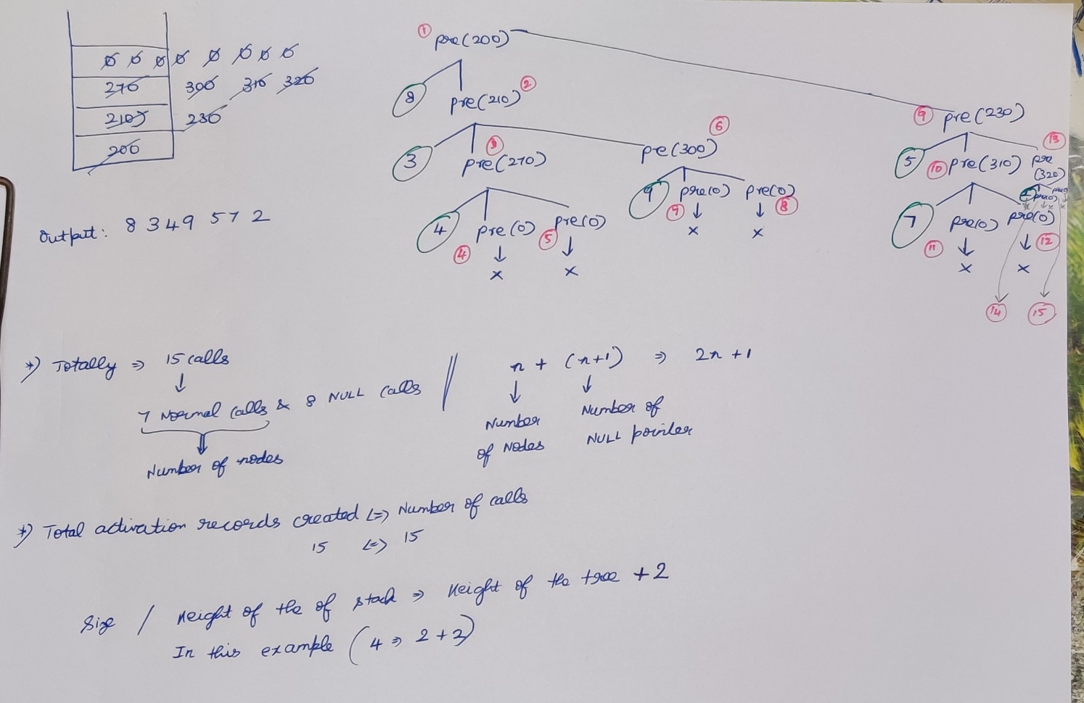



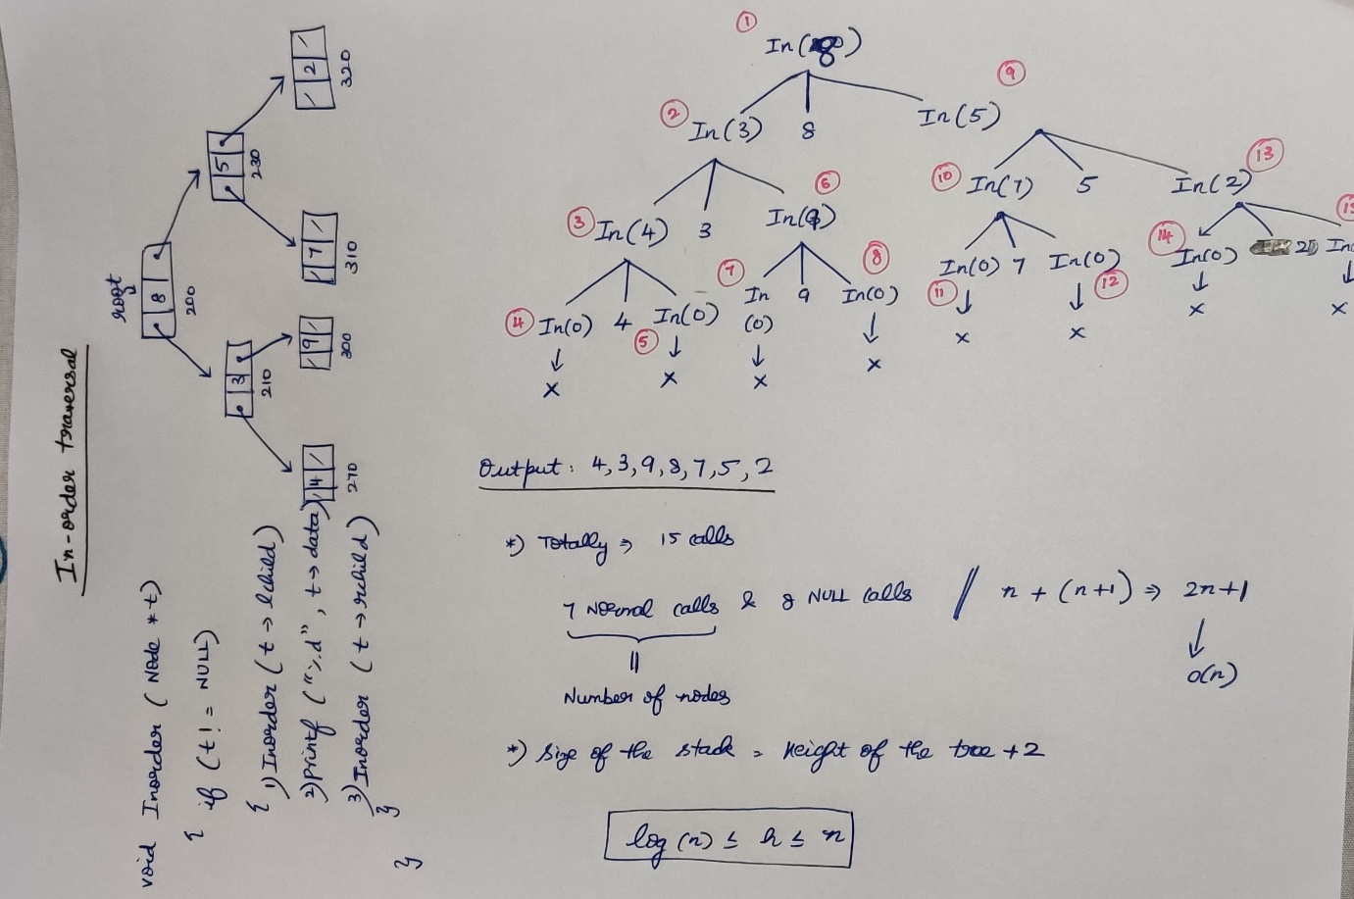

**Iterative tree traversal**

**Pre-order tree traversal**

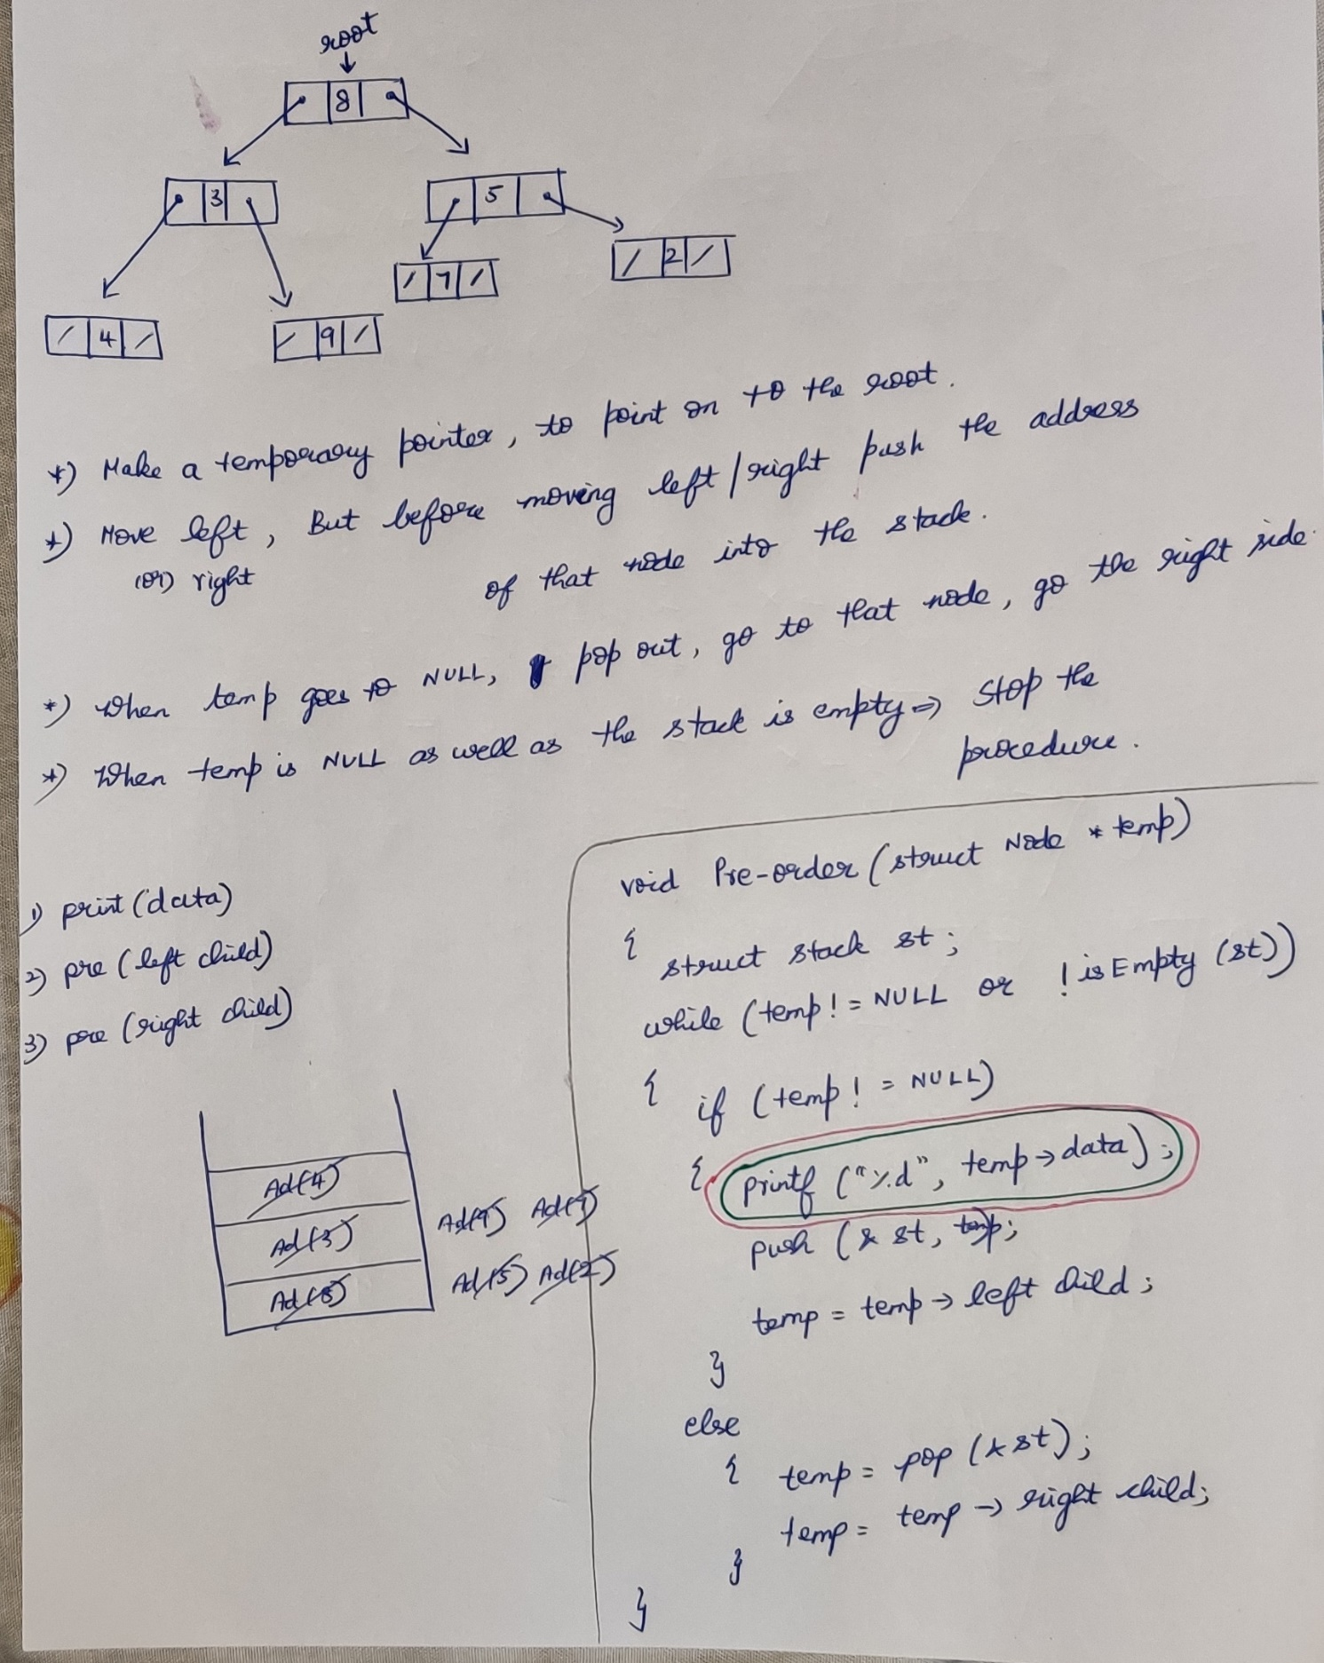

**In-order tree traversal**

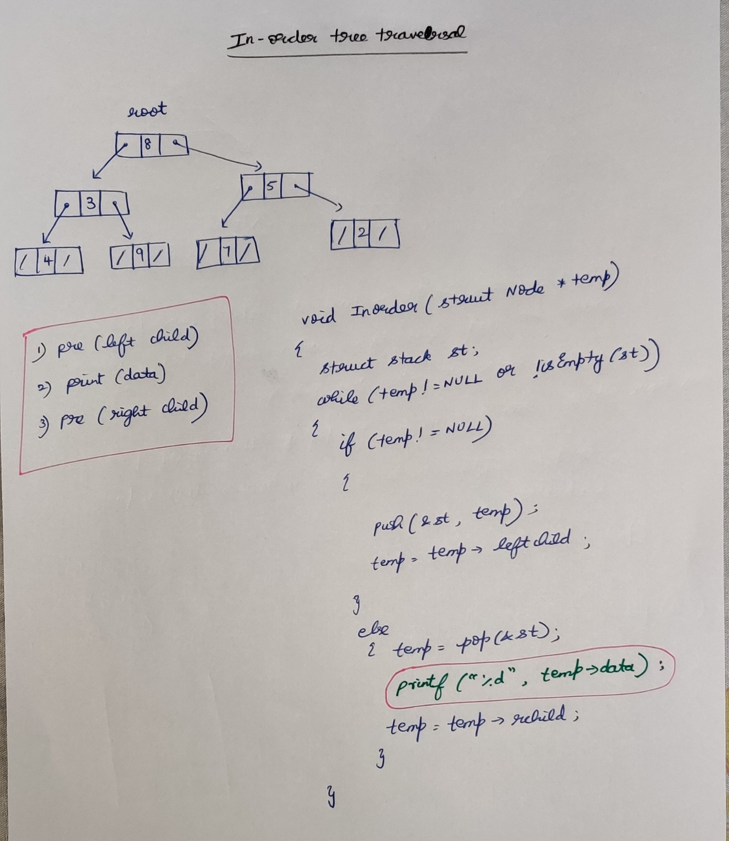

**Post-order tree traversal**

temp reaches NULL, Don’t print . Move to the right. Right also is NULL.

Then next address will be popped out. So will lose the control of the temp.

Before moving to the right once again push the address(temp) to the stack.   
So 1st time pushing 🡪 For moving to right.  
 2nd time pushing 🡪 For printing the value.

Both the time address’s are pushed, but how to differentiate ??  
1st time push the address (i.e +ve).   
2nd time, change address as -ve integer and then push.

